# Experiment No.: 03 Square-Root Extractor

|  |  |
| --- | --- |
| **Academic Year** | **: 2021-22 Sem : I** |
| **Class** | **: TY BTech Instrumentation & Control** |
| **Course Name** | **: Process Instrumentation** |
| **Course Code** | **: IC3231** |
| **Name** | **: Shaunak Deshpande** |
| **Division** | **: IC-C** |
| **Roll No.** | **: 39** |
| **G.R. No.** | **: 11911180** |

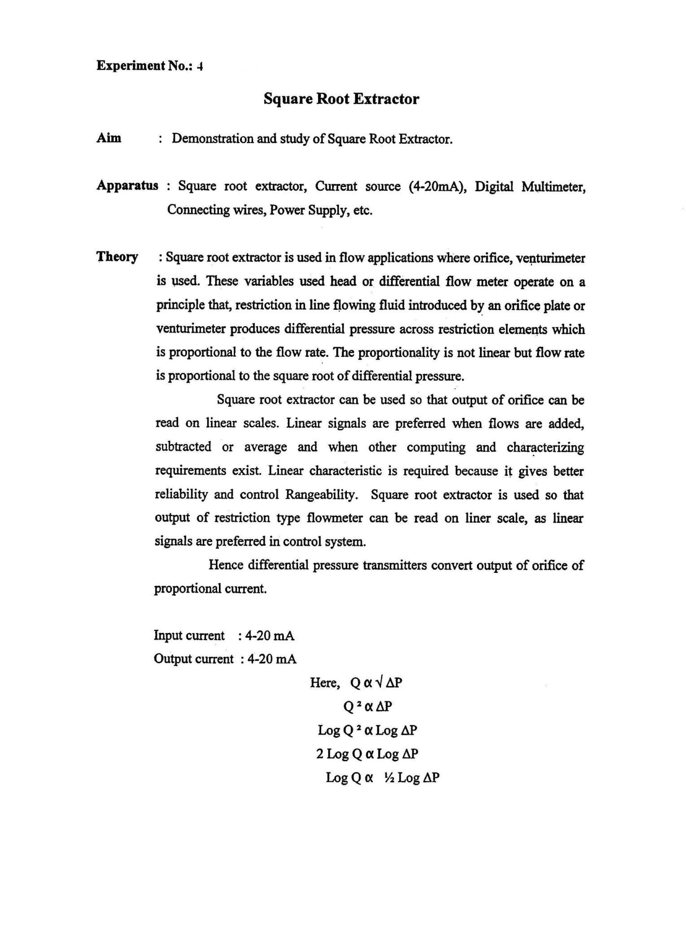

21

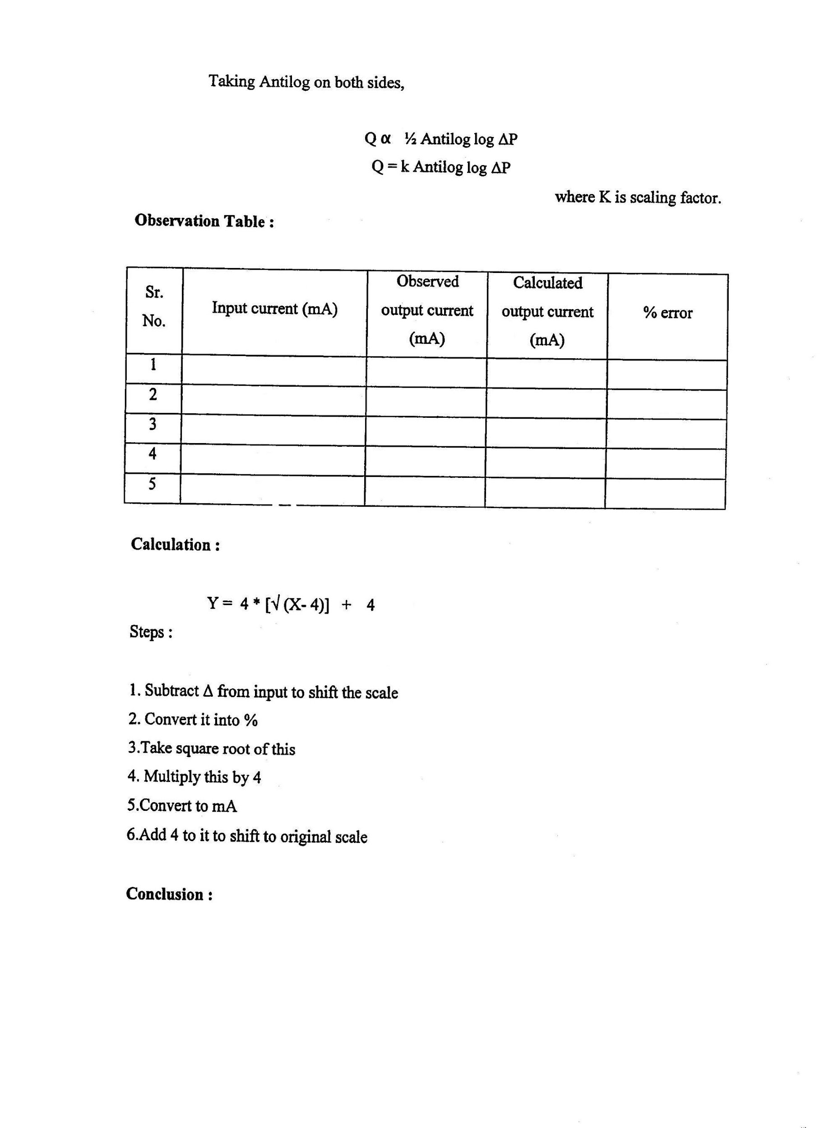

22

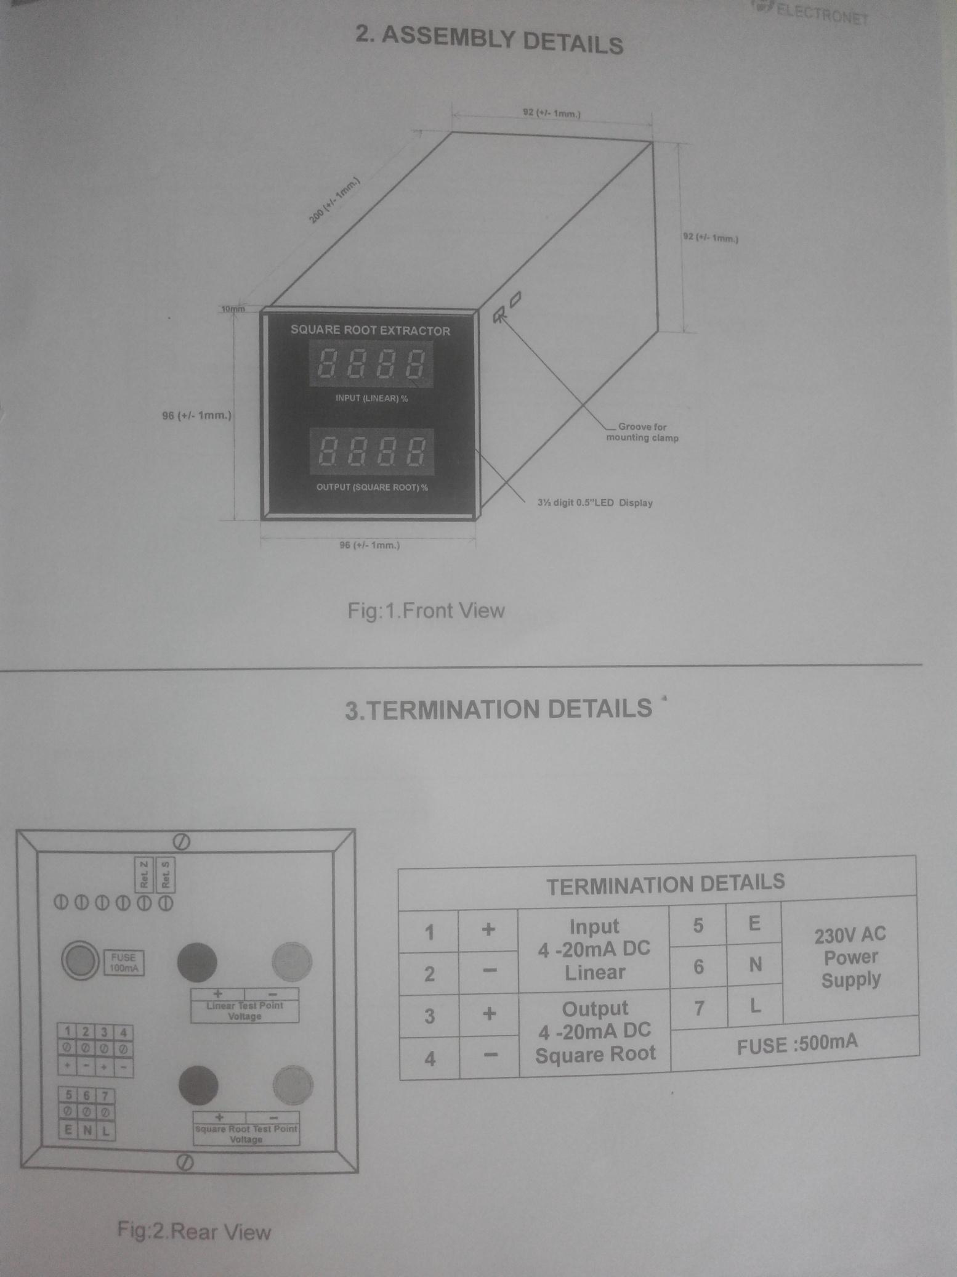

**Implementation of Square Root Extractor :**

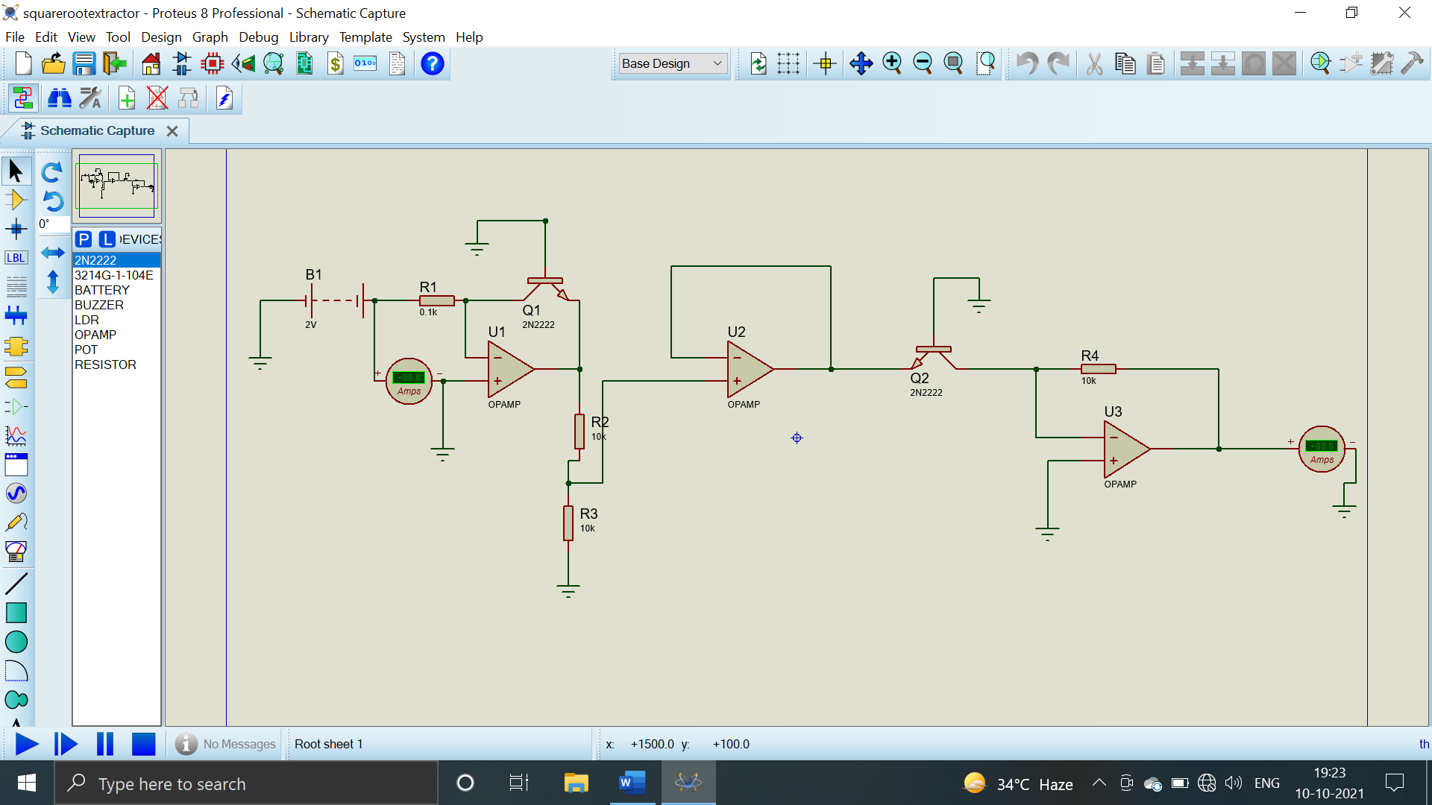

**Observation Table and Characteristics : (Screenshot of Excel sheet)**

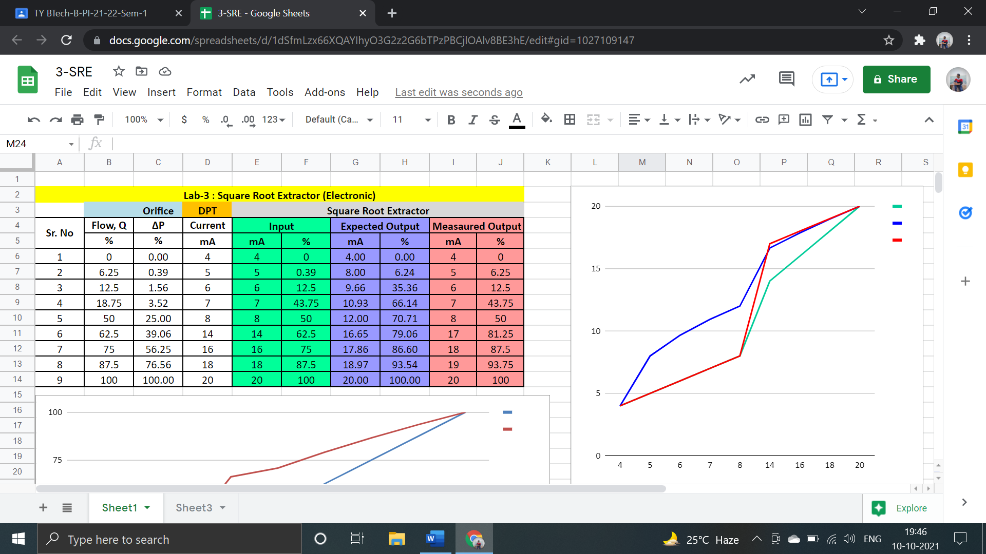

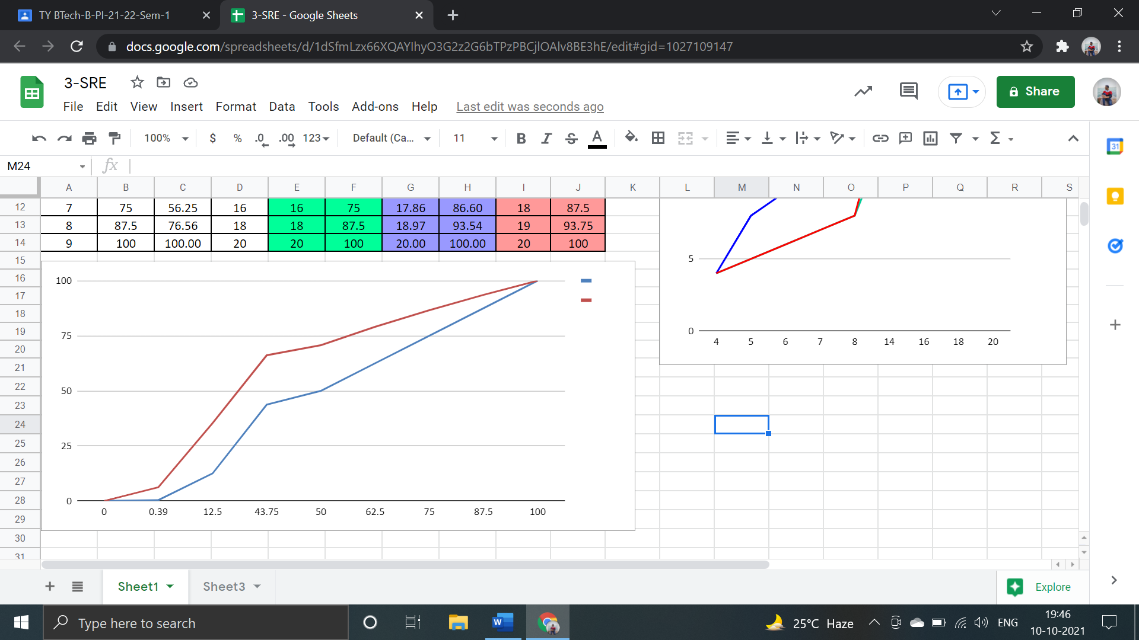

**Pneumatic Square Root Extractor:**

In a pneumatically operated square root extracting device having means for extracting the square root of an input signal from an output pneumatic signal thereof and comprising a movable means for acting on a flapper lever that controls a bleed nozzle of said device, said device has a movable wall carried by said device and defining an output signal chamber therewith whereby the position of said wall is determined by the pressure in said output signal chamber, said wall being operatively interconnected to said movable means to position the same relative to said flapper lever in relation to the pressure in said output signal chamber. The improvement wherein said movable means comprises a cam operatively interconnected to said movable wall and having a cam face that defines at least part of the involute of a circle and means operatively interconnecting said cam face to said flapper lever to control the same in relation to the movement of said cam by said movable wall.